Specifications
  - KBer-KR2-0123 PA-609 Automatic Adoption Product Line into SML
Version 1.0

Customer: | Berrang Holding Verwaltungsgesellschaft mbH
Project: | Berrang Holding Verwaltungsgesellschaft mbH Introduction
proALPHA version: | 9.3
proALPHA Installation(s): | DE (Mannheim)
GUI language: | German
Author: | Katharina Riedel
Created on: | 06.06.2024
Last change on: | 20.06.2024
Contact Customer: | Matthias Kunze

This document describes a modification or expansion of the standard software proALPHA and has been checked by the customer. The functional design in chapters 2 - 4 is hereby released for technical specification and costing in compliance with the requirements in section "Final Provisions":

......................................................
Date and Signature of Customer

Contents
1. [UPDATE THE TABLE] 4
1.1 [UPDATE THE TABLE] 4
1.2 [UPDATE THE TABLE] 4
1.3 [UPDATE THE TABLE] 4
1.4 [UPDATE THE TABLE] 4
2. [UPDATE THE TABLE] 5
2.1 [UPDATE THE TABLE] 5
2.2 [UPDATE THE TABLE] 5
2.2.1 [UPDATE THE TABLE] 5
2.2.2 [UPDATE THE TABLE] 7
2.2.3 [UPDATE THE TABLE] 7
2.3 [UPDATE THE TABLE] 7
3. [UPDATE THE TABLE] 9
3.1 [UPDATE THE TABLE] 9
3.2 [UPDATE THE TABLE] 9
4. [UPDATE THE TABLE] 11
4.1 [UPDATE THE TABLE] 11
4.2 [UPDATE THE TABLE] 11
4.3 [UPDATE THE TABLE] 11
5. [UPDATE THE TABLE] 12
5.1 [UPDATE THE TABLE] 12
5.1.1 [UPDATE THE TABLE] 12
5.1.2 [UPDATE THE TABLE] 12
5.1.3 [UPDATE THE TABLE] 12
6. [UPDATE THE TABLE] 13
7. [UPDATE THE TABLE] 14
7.1 [UPDATE THE TABLE] 14
7.2 [UPDATE THE TABLE] 14
8. [UPDATE THE TABLE] 15

Requirements

References
The request was accepted in the joint workshop with Berrang and proALPHA.
In the concept Quality Standard - ERP proALPHA - Berrang Group - Confluence (atlassian.net) and Concept Classification Systems, Features and Specifications - ERP proALPHA - Berrang Group - Confluence (atlassian.net)
Specified in [PA-609] KBer-KR2-0123 PA-609 Automatic adoption of product line into SML - Jira (atlassian.net)
Adjustments related to this adjustment:
KBer-KR2-0069 PA-382 Certificate and Document Management for Suppliers - File Storage - BCS (proalpha.com) - Synchronization of Part Classification Systems with Supplier Features
KBer-KR2-0072 PA-485 Expansion of Quality Standard in RFQ Lines - File Storage - BCS (proalpha.com) - Comparison of Suppliers via Classification Systems at Part and Supplier

Summary and Objectives
The product line is used to specify suppliers in case of demand. In the concept Request for Quote / Process - ERP proALPHA - Berrang Group - Confluence (atlassian.net) it is defined that suitable suppliers can be automatically selected via the part classification systems.
The contents of the product line (Product Line field) therefore have to be placed in the corresponding classification system to enable the automatic selection.

Description of requirements
Synchronization of the data from the Item Group field into a part classification system on the part.

Requirements Glossary (Terminology)

Term | Explanation
PCLS | Part Classification System
Table 1Requirements Glossary

Functional design

Summary of the Solution
The data of the product line (Product Line field) are to be synchronized with the PCLS main product group. The assignment and change of a product line to a part is to be automatically adopted into the features of the classification system of the part.

Description of the solution

Business Logic & GUI

Synchronization SML
The BS_Kopf table is closed by the "Synchronous" check box. "Product Line" added.
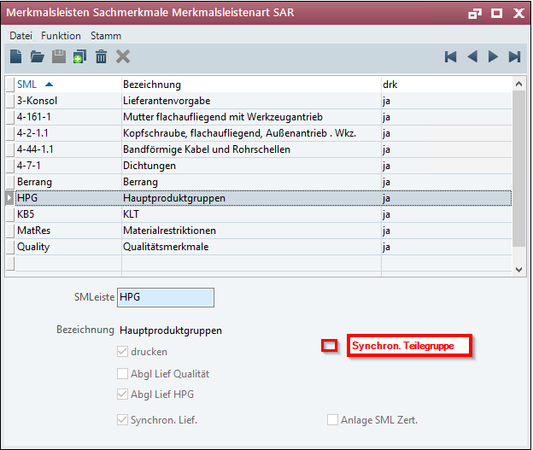
The check box has to be set for the classification system into which the data from the S_ArtGruppe table are to be synchronized. The check box may only be enabled for a classification system.
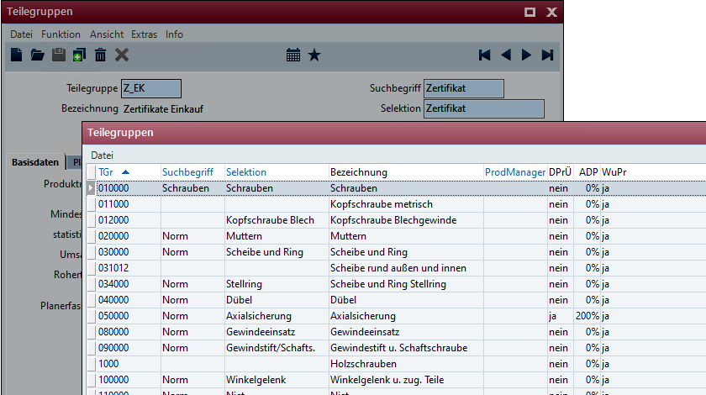

In the classification system, in which the "Synchronous" check box is enabled. product line", no manual features may be added or deleted.
The features are to be automatically created from the S_ArtGruppe table according to the following scheme:
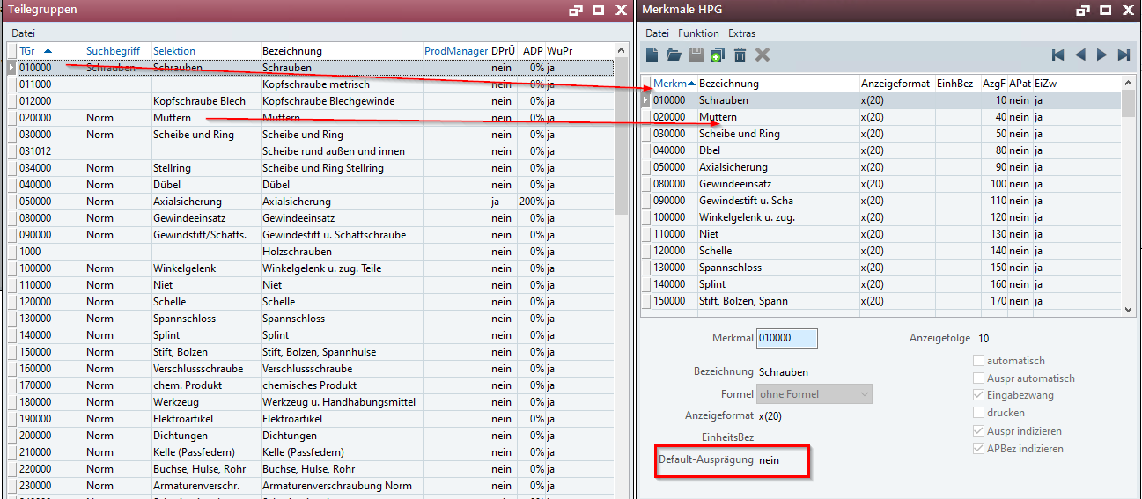
The specifications have to be created with Yes and No. The default value of the specification is No.
The check box cannot be disabled if the "Reconciliation Suppl HPG" check box is enabled at the same time. The "Reconciliation Suppl HPG" check box has to be disabled first. Only then can the check box from the "Synchronous" check box be disabled. "Product Line" can be removed.
BS_Kopf.xAbgLiefHPG table
Reference message:
"Disable not possible if Disp Ship HPG is enabled."
This is to prevent the data from being deleted or changed by mistake.

Specification Update for Part
The product line of the part is filled manually or adopted by means of copy templates.
The classification system, which contains the "Synchronous" check box product line" is automatically assigned to each part.
The specification of the feature corresponding to the product line is automatically set to Yes.
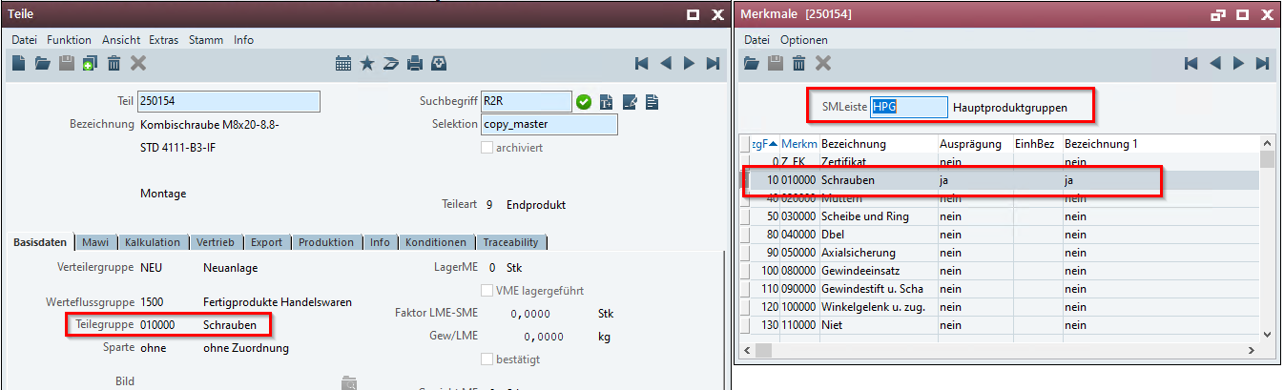
If the product line is changed, the specification of the feature is also to be changed
The old feature receives the specification "No", the new feature receives the specification "Yes".
If the "Synchronous" check box "Product Line" is disabled, the CLS remains assigned to the part, but without function in the context of the described customization. (Standard)
Note for rank: If the features are not to be used anymore, they have to be deleted manually from the classification system. (after disabling the "Synchronous" check box) Product line" possible)

Data Model
Another X field is to be implemented in the BS_Kopf table:

Field name | Label | Type | Format | Initial
xSyncPartGroup | Synchronous. Product Line | logical | Yes/No | No

Output

Differentiation
The customization refers to the tables, fields and programs mentioned.
These specifications do not automatically add functional extensions to the modules of the proALPHA environment, such as the DMS, Analyzer, reports, and forms. The proALPHA Help is not automatically extended either.
Changes to adjacent modules/programs must be described and defined in the specifications sheet.

Test cases
The specified test cases map the customization described here and are the basis for the acceptance of the software.

PCLS HPG
Pt | Explanation | Expected result | Test data
 | New check box is available | Check box can be set and deleted again
 | Test result (incl. screenshots)
 | Set check box | The contents of the S_ArtGruppe table are synchronized
 | Test result (incl. screenshots)
 | Disabled check box | The check box can only be disabled if the Reconciliation Suppliers HPG check box is disabled. The features are deleted when you disable it.
 | Test result (incl. screenshots)

Classification system HPG for the part
Pt | Explanation | Expected result | Test data
 | Setting the check box | Classification system is assigned to the part  Feature of the product line has the specification Yes
 | Test result (incl. screenshots)
 | Change of the product line | Old feature = no  New feature = yes
 | Test result (incl. screenshots)
 | Disable the check box | Classification system remains assigned,
 | Test result (incl. screenshots)
 | Disable the check box  Manually creating a new feature | Classification system remains assigned; feature can be selected
 | Test result (incl. screenshots)

Requirements

Technical Requirements
The use of proALPHA functionalities outside the concurrent user model (connection of external systems, background processing) requires the licensing of so-called software services.
"Use of proALPHA functionalities" refers to any use or access to the proALPHA infrastructure, e.g.
- Writing to proALPHA data structures
- Calling proALPHA classes and other business logic
- Opening proALPHA Services
The implementation described in the specifications therefore requires the following software services:
- <Please list services here, otherwise delete section>
- ...

Organizational Requirements

Notes about the go-live

Technical Design

<Template for Section>

GUI

Business Logic

Data Model

Final Provisions
These specifications form the basis for customer-specific extensions of the standard software proALPHA®.
The customer-specific extensions only cover the area defined in this specification sheet. Functionality beyond this scope is not provided.
Unless explicitly agreed otherwise, the customer-specific extensions are only created in German: no programs, program parts or data are translated into other languages. This also applies to the languages supported by ^{proALPHA®} in the standard version.
The customer-specific extensions are thoroughly tested before they are delivered. However, for technical reasons, it is not possible to perform the test under the same conditions and with the same data as the customer will use. It is therefore recommended to carefully check the functions in the real system environment after their delivery.
The Customer is aware that the transfer of the functions defined in this specification sheet to new versions of proALPHA® may require deviations in the display details or handling. This specification sheet also remains valid in this case, provided that there is a maintenance agreement for the customer-specific extensions defined in this specification sheet and no changes to the functionality have to be agreed on.
This specification sheet documents the customer-specific extensions. No other documentation beyond the specifications contained in this specification sheet is to be provided. Questions about customer-specific extensions are received and forwarded by the hotline.
By signing on page 1, you confirm:
that the specification sheet is accepted in this version and becomes part of the contract,
that this specification sheet defines the functional scope of the software to be created and that there are no side agreements regarding the functionality.

Annex

Table of Figures
No entries could be found for a table of figures.

Table of tables
[UPDATE THE TABLE] 4

Change History
Doc. -  Version | Date | Specialist | Initiator | Chapter | Explanation
1.0 |  | Katharina Riedel | Matthias Kunze | All | Initial new entry

